North British Police and PSUK National Sailing Championship
12-16 June 2017

SAILING INSTRUCTIONS

RULES

The Regatta will be governed by the rules as defined in the Racing Rules of Sailing (RRS).

ELIGIBILITY

Eligible competitors are those who have been invited by the North British Police Sailing Regatta Organisers.

Where boats are provided by a Charter Company they will be allocated to competitors by the Regatta Organising Committee. The condition of supplied equipment shall not be grounds for redress. This changes RRS Rule 62.

NOTICES TO COMPETITORS

Notices to competitors will be distributed at the daily skipper’s briefing.

CHANGES IN SAILING INSTRUCTIONS

Any change(s) to the sailing instructions will be made not less than one hour before the first start on the day it will take effect, except that any change to the schedule of races will be made by 22:00 on the day before it will take effect.

If it is necessary to make a change in the sailing instructions, Flag L will be displayed from the Committee Boat. In each case it will be the responsibility of the helm to acquaint themself with the change.

Late changes may also be announced via VHF Ch 72.

SCHEDULE OF RACES

Skipper’s Briefing
Day | Date | Time | Location
Monday | 12 JUN 2017 | 09:00 | Pontoon adjacent to ‘Inspirit’ (Committee Boat)
Tuesday | 13 JUN 2017 | 09:00
Wednesday | 14 JUN 2017 | 09:00
Thursday | 15 JUN 2017 | 09:00
Friday | 16 JUN 2017 | 09:00
Day | Date | Time of Start | Race Description
Monday | 12 June 2017 | 10:00 | Troon to Ardrossan  Ardrossan to Largs
Tuesday | 13 JUN 2017 | 10:00 | Largs to Inchmarnock  Inchmarnock to Tarbert
Wednesday | 14 JUN 2017 | 10:00 | Tarbert to Tarbert via The Otter Narrows
Thursday | 15 JUN 2017 | 10:00 | Tarbert to Kames  Followed by  Colintraive  to Rothesay
Friday | 16 JUN 2017 | 10:00 | Rothesay to Ardrossan –then onto Troon

As the distance to travel on several days is around 20 nm it is proposed to split this into 2 races (wind conditions permitting) in order to gather up the slower boats and add a bit more interest to proceedings. If there is insufficient wind to sail, the fleet will motor to the next race start position in the hope of prevailing weather conditions improving sufficiently to allow racing from that position. There will be an opportunity to break for lunch in between races. Start times for the second race will be communicated to the fleet via VHF Ch 72.

On days where more than one race is scheduled the start time of the second race of the day will be announced by VHF at the finish of the preceding race..

To alert boats that a race or sequence of races will begin soon, the orange starting line flag will be displayed with one sound five minutes before a warning signal is made.

RACING AREAS

The racing areas will be in the waters of the Firth of Clyde, The Kyles of Bute, Inchmarnock Water and Loch Fyne. (see nautical charts and the appendices to these sailing instructions for more information)

COURSES

The diagrams in the Appendices detail the courses, including the order in which marks are to be passed and the side on which each mark is to be left. The course diagrams are not to scale and indicate the approximate location and description of a mark. They do not accurately indicate the angle or distance between legs; please refer to nautical charts for accurate information.

The course to be sailed will be broadcast by VHF prior to the Warning Signal for the appropriate race.

MARKS

Detailed descriptions of marks can be seen in Appendix 6.

THE START

The starting sequence will be as follows:
Description | Time to Start | Signal
Alert Signal | 10 min | Orange Flag Displayed along with VHF announcement.
Warning Signal | 5 min | Announced over VHF
START | 0 min | 5 second countdown to start announced over VHF

The starting line will be between the orange flag on the committee boat and the designated start mark or an inflatable mark laid specifically for that task.

The Race Committee may announce boats that start prematurely (OCS) by VHF on Ch 72, the absence of such announcements shall not be grounds for redress. Boats that are OCS may exonerate themselves by completing a two turns penalty as soon as possible after the start, boats that start more than 20 seconds before the starting signal shall be scored OCS. This changes RRS Rule 62.

THE FINISH

The finishing line will be will be between the orange flag on the committee boat and the designated start mark or an inflatable mark laid specifically for that task.

Finished yachts shall not impede yachts that are still racing.

SHORTENED COURSE

If a race is shortened the Committee Vessel will display flag S and make 2 sound signals. Boats should finish between the committee vessel and the adjacent mark or landmark as advised by VHF.

TIME LIMITS

The time limit will be 18:00hrs each day.

PROTESTS AND REQUESTS FOR REDRESS.

Protest forms are available from the Committee Vessel. Protests shall be returned to the Committee Vessel along with a deposit of £1,000,000 (non-refundable) within the protest time limit.

The protest time limit is 60 minutes after the last boat has finished the last race of the day, or the race committee signals no more racing today, whichever is later.

Notices of protests by the race committee will be posted to inform boats under RRS 61.1(b).

Protests will be heard as soon as possible, in approximately the order of receipt. It is the responsibility of the Protestor, Protestee and Witnesses to make themselves available for the hearing.

On the last day of the Regatta a request for reopening a hearing shall be delivered:
(a) within the protest time limit if the party requesting reopening was informed of the decision on the previous day;
(b) no later than 30 minutes after the party requesting reopening was informed of the decision on that day.
This changes RRS Rule 66.

SCORING

One race is required to be completed to constitute a series.
- When fewer than 4 races have been completed, a boat’s series score will be the total of her race scores.
- When 4 or more races have been completed, a boat’s series score will be the total of her race scores excluding her worst score.

SAFETY REGULATIONS

Clydeport Operations Limited Restrictions.

NARROW CHANNELS. Attention is drawn to the International Regulations for the prevention of collisions at sea, 1972. Particular notice shall be taken of Rule 9b which states that “a vessel of less than 20m in length or a sailing vessel shall not impede the passage of a vessel which can safely navigate only within a narrow channel or fairway”. Whilst racing or on a passage in the Firth of Clyde north of Cumbrae Head yachts must regard any such recommended channels as a “Narrow Channel” within the meaning of the IRPCS 9b.

Furthermore Clydeport Operations Limited has decreed that any waters in the Firth of Clyde where vessels by virtue of their size, draught, speed or proximity to land, hazards and other vessels are unable to manoeuvre freely must be regarded as a “Narrow Channel”. Whilst racing any yacht which is unable for reasons of lack of wind or other cause, to sail clear of a large power driven vessel shall start her engine and/or paddle in order to clear and thereafter shall report full details to the race committee.

Competitors are reminded of the Clydeport Operations Limited Byelaw which prohibits yachts and other craft from manoeuvring within 100m of any ferry terminal. Particular regard should be paid to this when in the vicinity of the Caledonian Macbrayne facilities at Largs and Cumbrae.

Boats retiring must inform the Race Officer on VHF Ch 72 before leaving the sailing area.

A boat suffering a breakdown shall report to the Race Officer on VHF Ch 72 at the end of the race. It is the responsibility of each skipper to check the boat prior to racing and where appropriate report faults to the Charter Company.

The standing rigging of Charter boats will be set by the Charter Company and shall not be altered by the competitors. All equipment supplied by a Charter Company shall be carried in its appropriate place during racing.

REPLACEMENT OF CREW OR EQUIPMENT

Substitution of competitors shall not be permitted without prior written approval of the race committee.

RADIO COMMUNICATION

Radio communication between the Race Committee and competitors will be made on VHF Ch 72.

Except in an emergency, a boat shall neither make radio transmissions while racing nor receive radio communications not available to all boats. This restriction also applies to mobile telephones.

RIGHTS TO USE NAMES AND LIKENESSES

Competitors automatically grant to the organizing authority without payment the right in perpetuity to make, use and show any motion pictures, still pictures and live, taped or filmed television of or relating to the event.

PRIZES

The organising authority shall award prizes to the first three boats. Other prizes may be awarded, at the discretion of the organising authority.

RISK STATEMENT

Rule 4 of the Racing Rules of Sailing states: "The responsibility for a boat’s decision to participate in a race or to continue racing is hers alone."

Sailing is by its nature an unpredictable sport and therefore inherently involves an element of risk. By taking part in the event, each competitor agrees and acknowledges that:

(a) They are aware of the inherent element of risk involved in the sport and accept responsibility for the exposure of themselves, their crew and their boat to such inherent risk whilst taking part in the event;

(b) They are responsible for the safety of themselves, their crew, their boat and their other property whether afloat or ashore;

(c) They accept responsibility for any injury, damage or loss to the extent caused by their own actions or omissions;

(d) Their boat is in good order, equipped to sail in the event and they are fit to participate;

(e) The provision of a race management team, patrol boats and other officials and volunteers by the event organiser does not relieve them of their own responsibilities;

(f) The provision of patrol boat cover is limited to such assistance, particularly in extreme weather conditions, as can be practically provided in the circumstances.

INSURANCE

Each participating boat shall be insured with valid third-party liability insurance with a minimum cover of £2,000,000 per event or the equivalent.
Appendix 1 – Troon to Ardrossan Courses. Monday 12 June

Holy
Island
Mull of Kintyre
Isle of Bute
Isle of Arran
Ayr
Troon
Ardrossan
Hunterston
Largs

Great Cumbrae

Little Cumbrae

West Kilbride

Lady Isle

Race 1

Course 1

Start (Off Troon) - Lady Isle (Stbd) – Finish (Off West Kilbride)

Course 2

Start (Off Troon) - Lady Isle (Port) - Finish (Off West Kilbride)

Race 2

Course 1

Start (Off West Kilbride) – Little Cumbrae (stb) – Great Cumbrae (port) – Finish off Largs

Course 2

Start (off West Kilbride) – Little Cumbrae (port) – Finish off Largs

Appendix 2 – Largs to Tarbert Courses. Tuesday 13 June

ISLAND OF ARRAN

TARBERT
SKELMORLIE
Sgat Mor
ISLAND OF BUTE
LARGS

Inchmarnock sound

Portachur Green buoy

Ardrossan

Race 1

Course 1

Start (Off Largs) – Little Cumbrae (port) – Portachur buoy (port) - Finish (Off Inchmarnock Sound)

Course 2

Start (Off Largs) – Little Cumbrae (stb) - Finish (Off Inchmarnock Sound)

Race 2

Course 1

Start (Inchmarnock Sound) – Sgat Mor (port) – Finish (off Tarbert)

Course 2

Start (Inchmarnock Sound) – Sgat Mor (stb) – Finish (off Tarbert)

Appendix 3 – Tarbert to Tarbert Courses. Wednesday 14 June

Race 1

Course 1

Start (Off Tarbert) – Q (Stbd) – Finish (Off Otter Narrows)
Q
TARBERT
SHALLOWS
LOCH GILP

Race 2

Start (Otter Narrows) – Q (port) –

Finish (off Tarbert)

Appendix 4 –Tarbert to Rothesay Courses. Thursday 15 June

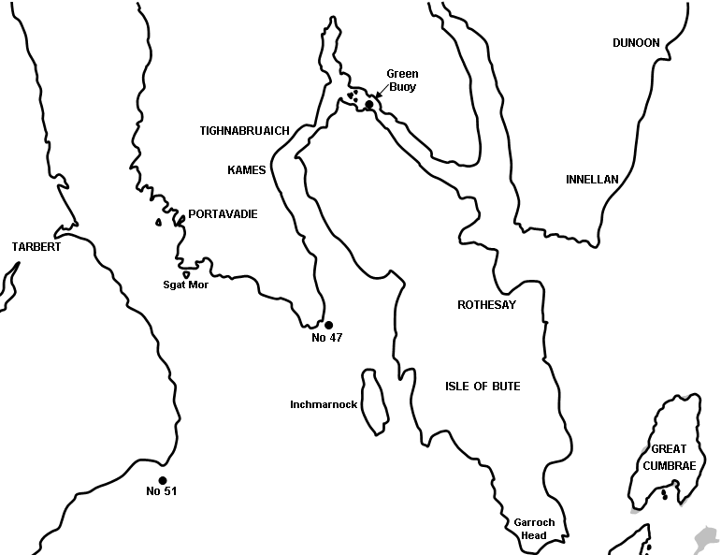

Race 1 (Tarbert to Kames)

Start (Off Tarbert) - Sgat Mor Island (Stbd), No 47 (port), Finish (Off Kames)

Stop for lunch

Proceed through the narrows and await second start near the green buoy north of the Colintraive ferry.

Race 2 (Colintraive Ferry to Rothesay)

Start (near Green Buoy), Finish (Off Rothesay)

Appendix 5 – Rothesay – Troon. Friday 16 June
Hun3
ISLE of BUTE
ROTHESAY
WEMYSS BAY
TOWARD
POINT
GREAT
CUMBRAE
LITTLE
CUMBRAE
LARGS
LARGS YACHT HAVEN
SKELMORLIE
Mountstuart
No35

-
Race 1

Course 1 - Start (off Rothesay) – No. 35 (stb) – Mountstewart buoy (stb) – Little Cumbrae (stb) – Finish West Kilbride

Course 2 – Start (off Rothesay – No35 (port) – Mountstewart (port) – Little Cumbrae (port) – Finish West Kilbride

